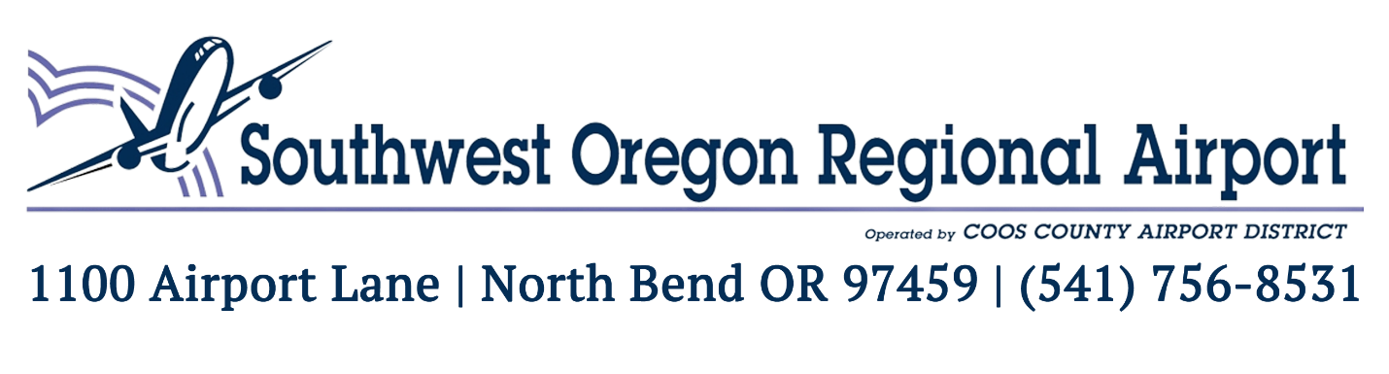

**Airport Park Steering Committee Meeting**  
June 12, 2025 – 12:00 pm (Noon)

Southwest Oregon Regional Airport Terminal Board Room

**To Join the Meeting Remotely**:

https://zoom.us/j/91589296930?pwd=RzAzb05aN3JaVkFXalFPVmtwbWNKQT09  
Meeting ID: 915 8929 6930 Passcode: 0000

Cancelled

One tap mobile  
+13462487799,,91589296930#,,,,*0000# US (Houston)  
+16694449171,,91589296930#,,,,*0000# US

**AGENDA**

**Call to Order**

**1) Review Minutes**

       a) Motion for approval of minutes from March 13, 2025

**2) Committee Reports**  
     a) Airport Update

     b) Rotary Update

**3) Action Items**

     a) None

**Public Comments**

**Adjourn**

Next Meeting Date: Thursday, July 10, 2025 at Noon